

Programme Name: ________**BCS HONS**_______________________________________

Course Code: __**CSC 3201**________

Course Name: _______**Artificial Intelligence**_____________________________

**Assignment** / Lab Sheet / Project / Case Study No. _**1**___

Date of Submission: ______**7/12/2021**_____________

**Submitted By: Submitted To:**

Student Name**: Dipesh Tha Shrestha** Faculty Name**: Prakash Chandra**

IUKL ID: **041902900028** Department**: LMS**

Semester**: Fourth Semester**

Intake**: September 2019**

1. **Explain the concept of artificial intelligence. Explain the application of AI in various fields.**

**Answer:**

Artificial intelligence (AI) refers to the simulation of human intelligence in machines that are programmed to think like humans and mimic their actions. The term may also be applied to any machine that exhibits traits associated with a human mind such as learning and problem-solving. The ideal characteristic of artificial intelligence is its ability to rationalize and take actions that have the best chance of achieving a specific goal.

Artificial Intelligence has various applications in today's society. It is becoming essential for today's time because it can solve complex problems with an efficient way in multiple industries, such as Healthcare, entertainment, finance, education, etc. AI is making our daily life more comfortable and fast. The application of AI in Various fields are:

* **AI in Robotics:**

Artificial Intelligence has a remarkable role in Robotics. Usually, general robots are programmed such that they can perform some repetitive task, but with the help of AI, we can create intelligent robots which can perform tasks with their own experiences without pre-programmed. Humanoid Robots are best examples for AI in robotics, recently the intelligent Humanoid robot named as Erica and Sophia has been developed which can talk and behave like humans.

* **AI in Gaming**

Another sector where Artificial Intelligence applications have found prominence is the gaming sector. AI can be used to create smart, human-like NPCs to interact with the players. It can also be used to predict human behavior using which game design and testing can be improved. The Alien Isolation games released in 2014 uses AI to stalk the player throughout the game. The game uses two Artificial Intelligence systems - ‘Director AI’ that frequently knows your location and the ‘Alien AI,’ driven by sensors and behaviors that continuously hunt the player.

* **AI in Marketing**

Artificial intelligence applications are popular in the marketing domain as well. Using AI, marketers can deliver highly targeted and personalized ads with the help of behavioral analysis, pattern recognition, etc. It also helps with retargeting audiences at the right time to ensure better results and reduced feelings of distrust and annoyance. AI can help with content marketing in a way that matches the brand's style and voice. It can be used to handle routine tasks like performance, campaign reports, and much more. Chatbots powered by AI, Natural Language Processing, Natural Language Generation, and Natural Language Understanding can analyze the user's language and respond in the ways humans do.

* **AI in Healthcare**

Artificial Intelligence finds diverse applications in the healthcare sector. AI is used in healthcare to build sophisticated machines that can detect diseases and identify cancer cells. AI can help analyze chronic conditions with lab and other medical data to ensure early diagnosis. AI uses the combination of historical data and medical intelligence for the discovery of new drugs.

* **AI in Social Media**

On Instagram, AI considers your likes and the accounts you follow to determine what posts you are shown on yours explore tab. Artificial Intelligence is also used along with a tool called DeepText. With this tool, Facebook can understand conversations better. It can be used to translate posts from different languages automatically. AI is used by Twitter for fraud detection, removing propaganda, and hateful content. Twitter also uses AI to recommend tweets that users might enjoy, based on what type of tweets they engage with.

* **AI in education**:

AI can automate grading so that the tutor can have more time to teach. AI chatbot can communicate with students as a teaching assistant. AI in the future can be work as a personal virtual tutor for students, which will be accessible easily at any time and any place.

Therefore, this above are the various application field of AI.

1. **Explain the concept of intelligence agent? With example explain different types of intelligent agent**

**Answer:** An intelligent agent is a program that can make decisions or perform a service based o its environment, user input and experiences. These programs can be used to autonomously gather information on a regular, programmed schedule or when prompted by the user in real time. Intelligent agents may also be referred to as bot. An intelligent agent may learn from the environment to achieve their goals. A thermostat is an example of an intelligent agent.

Following are the main four rules for an AI agent:

Rule 1: An AI agent must have the ability to perceive the environment.

Rule 2: The observation must be used to make decisions.

Rule 3: Decision should result in an action.

Rule 4: The action taken by an AI agent must be a rational action.

**Different types of intelligent agent are:**

* **Simple Reflex agent**

The Simple reflex agents are the simplest agents. These agents take decisions on the basis of the current percepts and ignore the rest of the percept history. These agents only succeed in the fully observable environment. The Simple reflex agent does not consider any part of percepts history during their decision and action process. The Simple reflex agent works on Condition-action rule, which means it maps the current state to action. Such as a Room Cleaner agent, it works only if there is dirt in the room.

* **Model-based reflex agents**

It works by finding a rule whose condition matches the current situation. A model-based agent can handle partially observable environments by use of model about the world. The agent has to keep track of internal state which is adjusted by each percept and that depends on the percept history. The current state is stored inside the agent which maintains some kind of structure describing the part of the world which cannot be seen.

* **Goal-based agents**

These kind of agents take decision based on how far they are currently from their goal (description of desirable situations). Their every action is intended to reduce its distance from the goal. This allows the agent a way to choose among multiple possibilities, selecting the one which reaches a goal state. The knowledge that supports its decisions is represented explicitly and can be modified, which makes these agents more flexible. They usually require search and planning. The goal-based agent’s behavior can easily be changed.

* **Learning Agent**

A learning agent in AI is the type of agent which can learn from its past experiences or it has learning capabilities. It starts to act with basic knowledge and then able to act and adapt automatically through learning. A learning agent has mainly four conceptual components, which are:

**Learning element**: It is responsible for making improvements by learning from the environment

**Critic**: Learning element takes feedback from critic which describes how well the agent is doing with respect to a fixed performance standard.

**Performance element**: It is responsible for selecting external action

**Problem Generator**: This component is responsible for suggesting actions that will lead to new and informative experiences.

* **Utility-based agents**

These agents are similar to the goal-based agent but provide an extra component of utility measurement which makes them different by providing a measure of success at a given state. Utility-based agent act based not only goals but also the best way to achieve the goal. The Utility-based agent is useful when there are multiple possible alternatives, and an agent has to choose in order to perform the best action. The utility function maps each state to a real number to check how efficiently each action achieves the goals.

**3.**

**a. Differentiate between informed and uninformed search.**

Informed Search algorithms have information on the goal state which helps in more efficient searching. This information is obtained by a function that estimates how close a state is to the goal state. Example: Greedy Search and Graph Search.

Uninformed search algorithms have no additional information on the goal node other than the one provided in the problem definition. The plans to reach the goal state from the start state differ only by the order and length of actions. Examples: Depth First Search and Breadth-First Search.

Differentiate between informed and uninformed search is given below:

| **BASIS FOR COMPARISON** | **INFORMED SEARCH** | **UNINFORMED SEARCH** |
| --- | --- | --- |
| Basic | Uses knowledge to find the steps to the solution. | No use of knowledge |
| Efficiency | Highly efficient as consumes less time and cost. | Efficiency is mediatory |
| Cost | Low | Comparatively high |
| Performance | Finds solution more quickly | Speed is slower than informed search |
| Algorithms | Heuristic depth first and breadth-first search, and A* search | Depth-first search, breadth-first search and lowest cost first search |

**b. Consider the following map:**

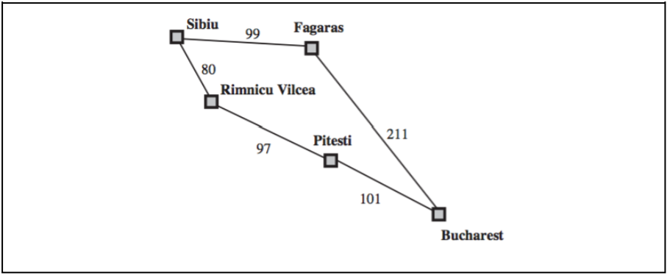

1. **With explanation, find the optimal cost to get from Sibiu to Bucharest using Uniform Cost Search**.

Solution:

The problem is to get from Sibiu to Bucharest. The successors of Sibiu are Rimnicu Vilcea and Fagaras, with costs 80 and 99, respectively. The least-cost node, Rimnicu Vilcea, is expanded next, adding Pitesti with cost 80 + 97 = 177. The least-cost node is now Fagaras, so it is expanded, adding Bucharest with cost 99 + 211 = 310. Now a goal node has been generated, but uniform-cost search keeps going, choosing Pitesti for expansion and adding a second path to Bucharest with cost 80 + 97 + 101 = 278. Now the algorithm checks to see if this new path is better than the old one; it is, so the old one is discarded. Bucharest, now with g-cost 278, is selected for expansion and the solution is returned.

Therefore, Optimal cost to get from Sibiu to Bucharest is 278.